1.81: a)
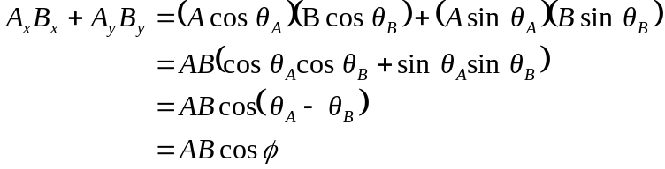

where the expression for the cosine of the difference between two angles has been used (see Appendix B).

b) With 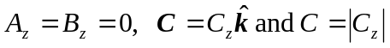. From Eq. (1.27),
